Part 1 - A/B Testing

The product team has asked for help coming up with an A/B test to increase reader engagement on our site. Please go to [businessinsider.com](http://www.businessinsider.com) and browse through the site prior to answering the below questions.

1. What do you think is something we can A/B test on our site that would help us achieve the goal of increasing user engagement?
   * 1. In this instance, engagement should be defined as a user taking action on the website in the form of:
        1. clicks (to articles or images), social sharing, subscription sign-up, email newsletter sign-up, video views, time on page, or scrolling
     2. For this test we will examine subscription signups. I chose this metric because the newsletter is one of the most effective ways to communicate with customers directly.
        1. Newsletters are also a highly attractive way for advertisers to reach a subscription base.
2. Describe how you would set up this A/B test so it is effective. Include an explanation of your thinking.
   1. For an A/B test to be effective, we must look at the difference between 2 versions of page we are testing. In order to be accurate, we must have only 1 difference between the 2 versions, that way we can be sure that the difference on one page is the only thing that could have increased or decreased engagement.
   2. For example:
      1. We have 1 version of the website that has an email signup pop-up (something that would appear in the window that the user must opt out of looking at), and 1 version of the website that has a newsletter sign-up stationary in the corner.
      2. We would then measure the difference between sign up rates between the two versions. Whichever has the higher rate is more successful and we should implement that version on the website.
3. Which success metrics would you choose for this A/B test and why?
   1. We will measure the difference between signups on each page.
   2. For a successful A/B test, we must ensure that both groups (testing and control) have enough of a sample size to be statistically significant.
   3. The test group will have the testing treatment (the subscription pop-up), and the control group will have the stationary subscription sign up.
   4. The primary metric for success will be the in sign-up rates.
      1. We want to make sure we look at the signup *rate*s to be able to compare “apples to apples”.
      2. Whichever treatment has the higher sign up rate will be the successful treatment that we will give to the final website.
      3. Finally, we want to ensure statistical significance ( to ensure that the difference between the 2 groups is due to the treatment, rather than randomness). This is found using a simple Z-test, calculated subtracting the mean of the distribution from the value and divided by the standard deviation. ([source](https://mixpanel.com/topics/statistical-significance/#:~:text=Statistical%20significance%20is%20the%20likelihood,a%20certain%20statistic%20is%20reliable.))
4. How would you determine whether the test was a success?
   1. Success is determined by a statistically significant difference between both treatment groups. Whichever group has the higher subscription rate will be considered successful.

Part 2 - Two Feature Problem

The product team has created two different features that drive readers to the Business and Insider homepages and is considering removing one of these features to clean up the article pages.

1. Use the data provided for each site and details about the features below to perform an analysis. Write up your findings and a recommendation in a document. Feel free to include any charts you think are necessary to support your findings and recommendation.
2. Outside of quantitative analysis, are there any other qualitative aspects to consider for this decision?
3. Do you think you are missing any data to fully make a decision? Please explain why or why not.
4. Write up your findings and recommendation in the form of an email to the product manager.

Feature 1: Recirculation Bullet

* The last bullet in a list of summary bullets at the beginning of every article.
* The feature is visible on both desktop and mobile devices.
* The bullet is also visible on all platforms outside of the direct site, such as Facebook Instant Articles, AMP, and a variety of distribution partners, such as Yahoo and MSN.

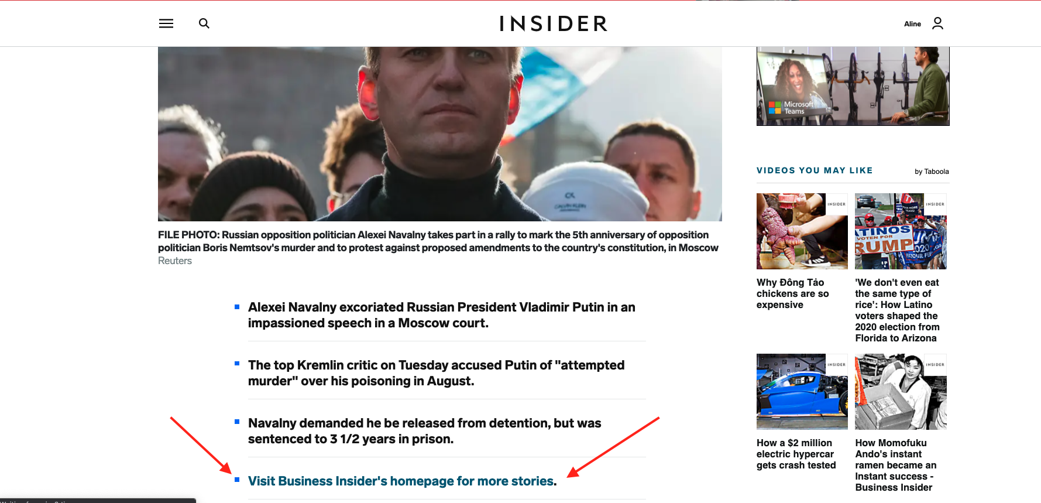

Feature 2: “Back to homepage” button

* Located on every post page in the top left corner.
* The button is only visible on mobile devices.
* The button is only visible on the direct sites and AMP. The button is not visible on platforms such as Facebook Instant Articles and our distribution partners, such as Yahoo and MSN.

